GUI



Figure 1: **GUI Design – Login Page**

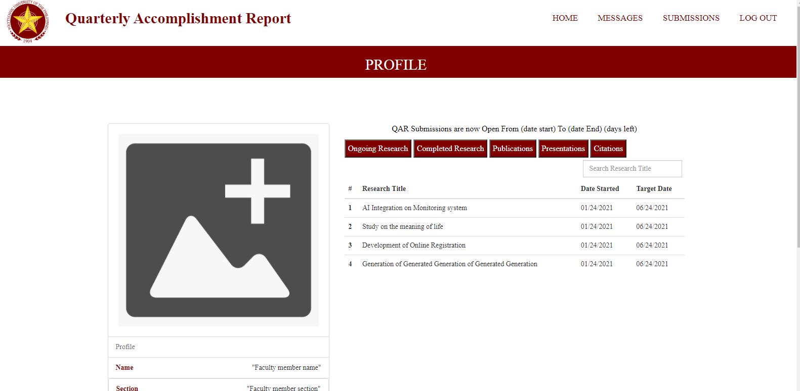

Figure 2: **GUI Design – Faculty Account Page(Top)**

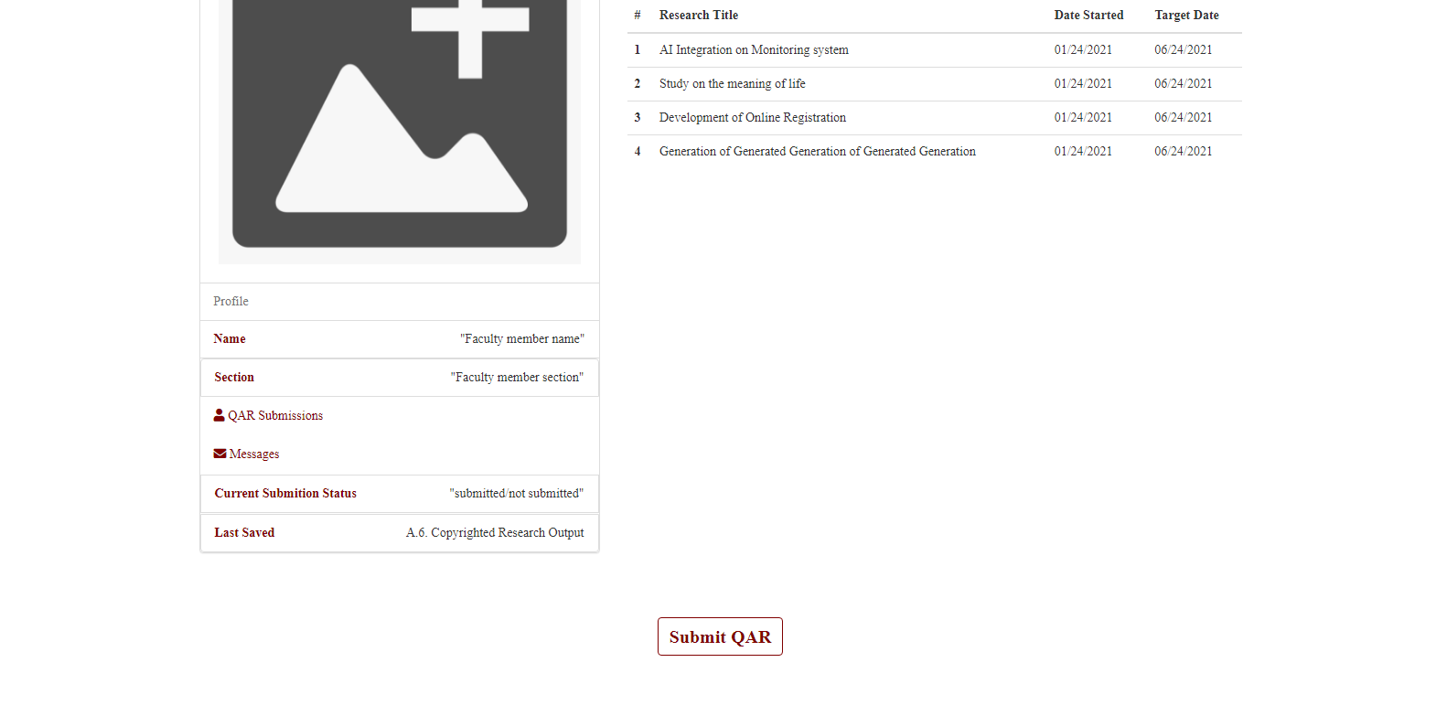

Figure 2: **GUI Design – Faculty Account Page(Bottom)**

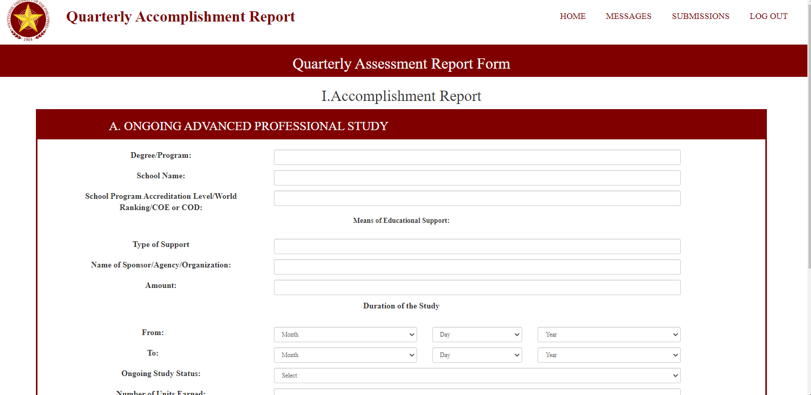

Figure 3: **GUI Design – QAR Form (1st Part) Top**

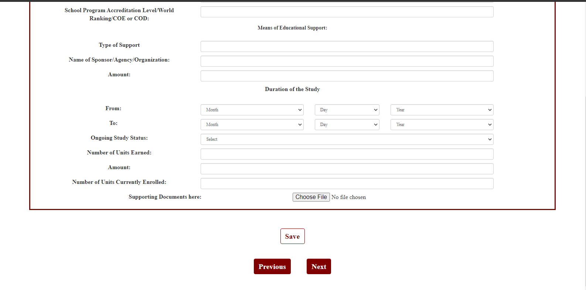

Figure 4: **GUI Design – QAR Form (1st Part) Bottom**

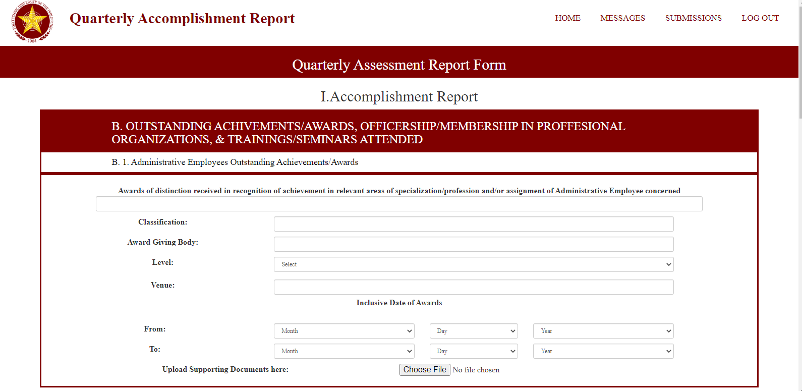

Figure 5: **GUI Design – QAR Form (2nd Part)**

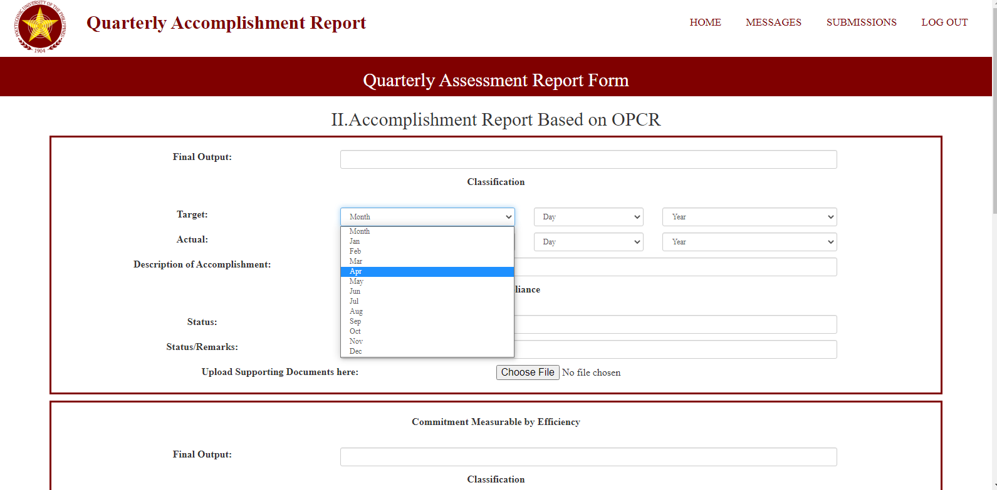

Figure 6: **GUI Design – QAR Form (3rd Part)**

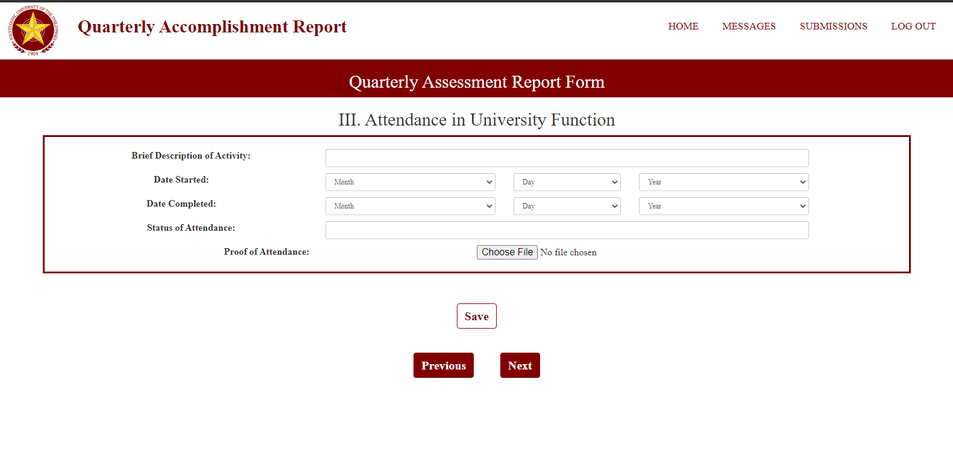

Figure 7: **GUI Design – QAR Form (4th Part)**

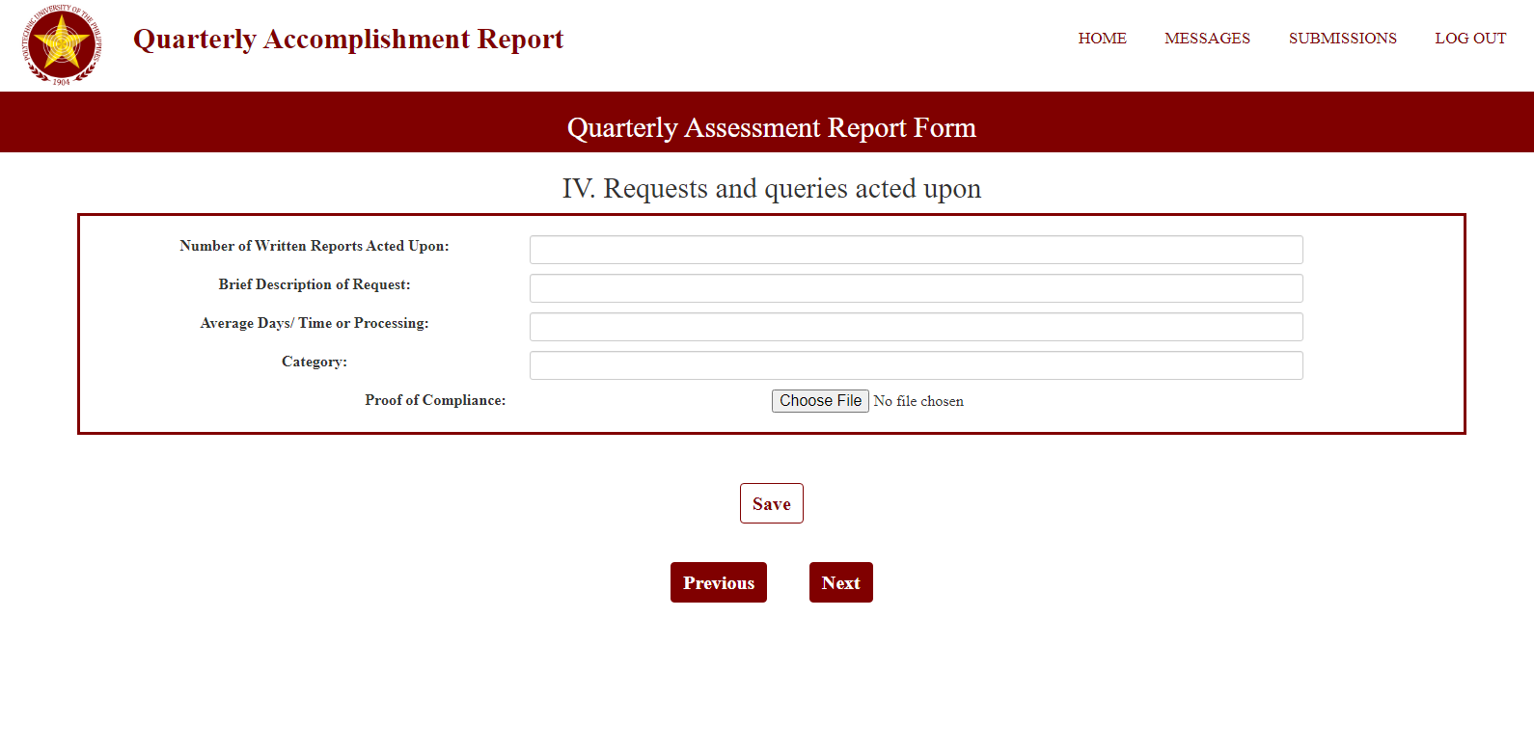

Figure 8: **GUI Design – QAR Form (5th Part)**

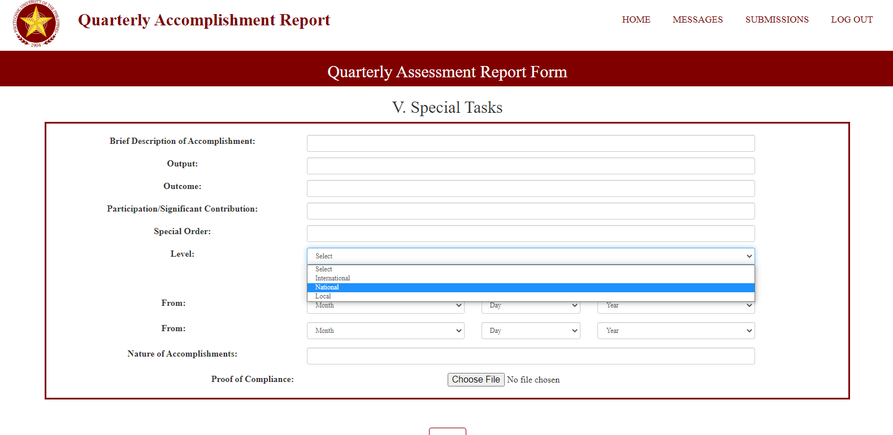

Figure 9: **GUI Design – QAR Form (6th Part)**

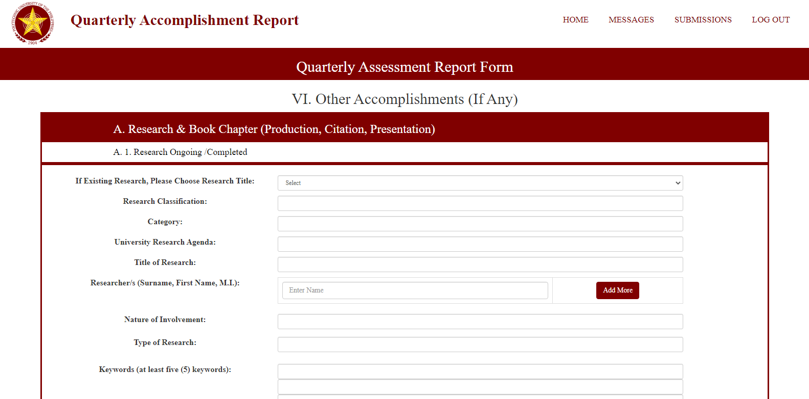

Figure 10: **GUI Design – QAR Form (7th Part)**

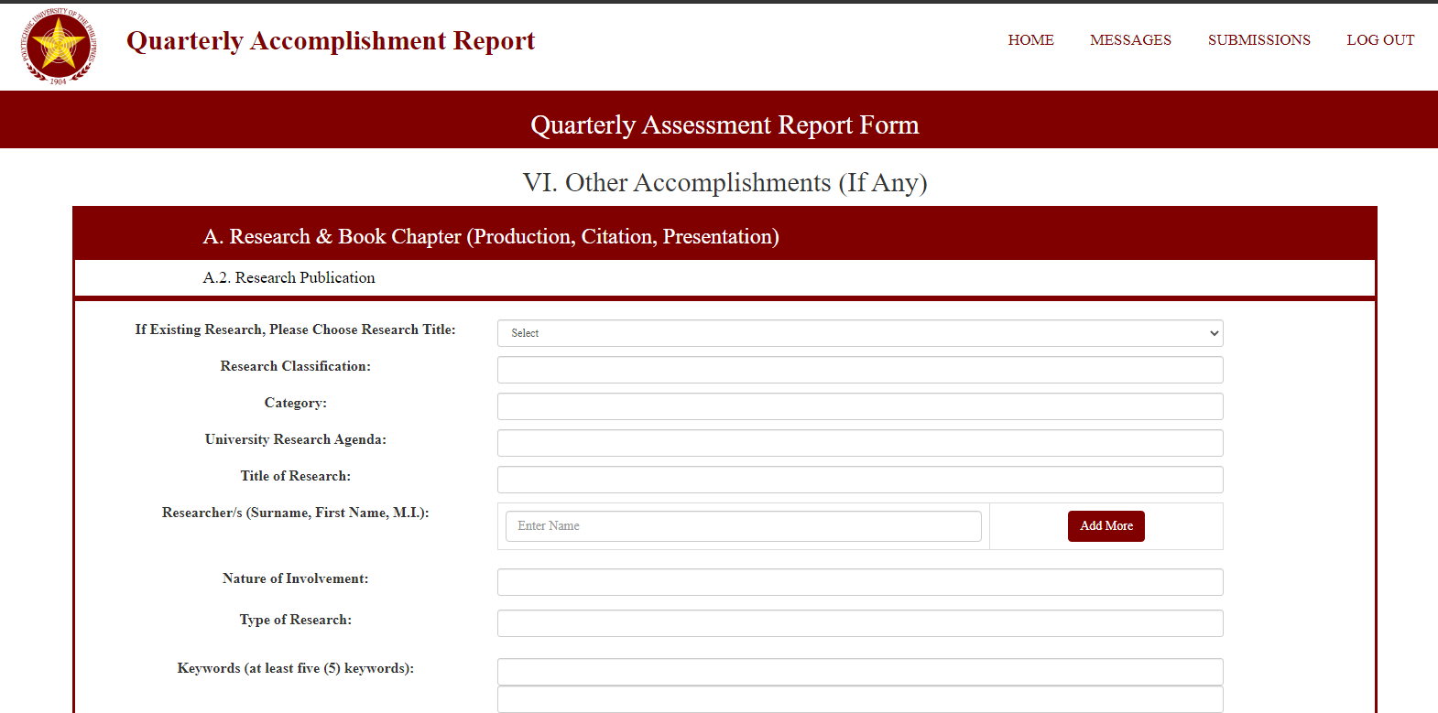

Figure 11: **GUI Design – QAR Form (8th Part)**

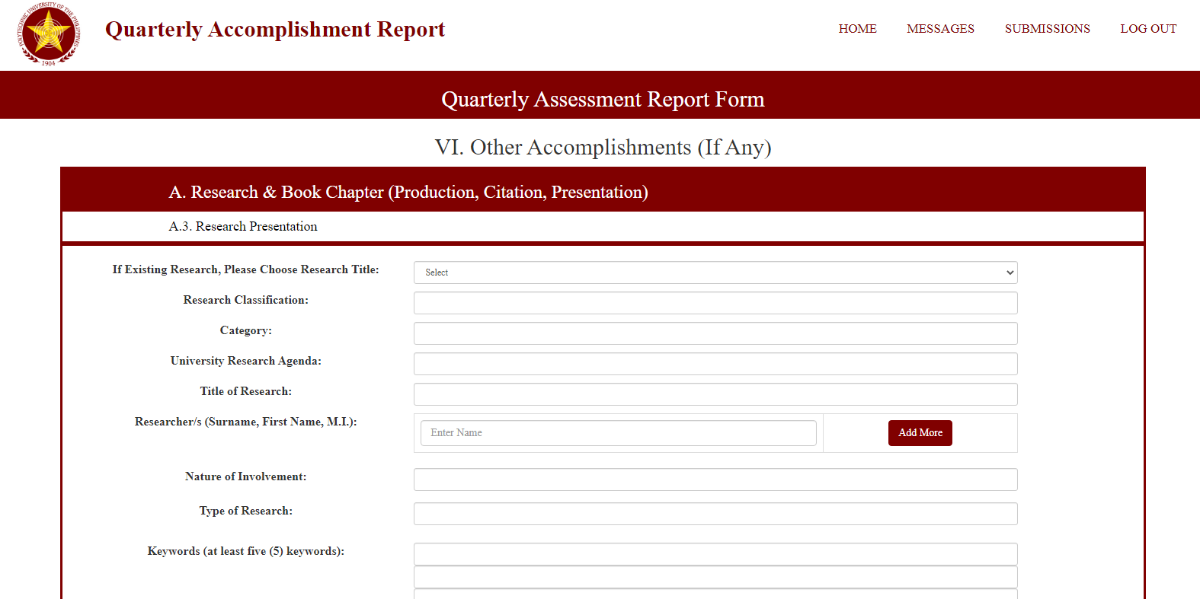

Figure 12: **GUI Design – QAR Form (9th Part)**

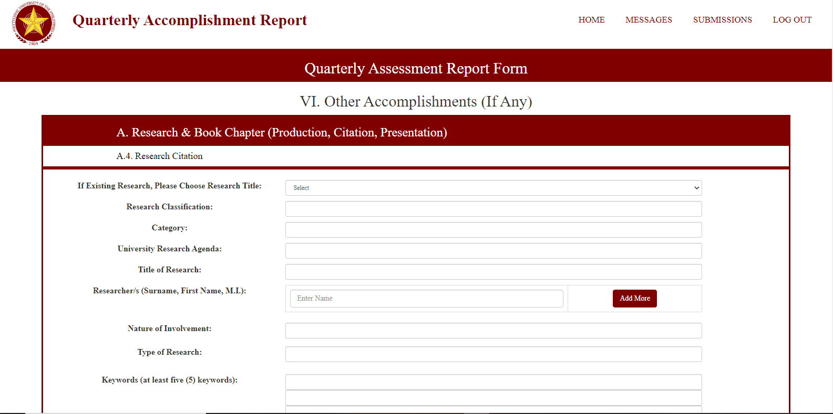

Figure 13: **GUI Design – QAR Form (10th Part)**

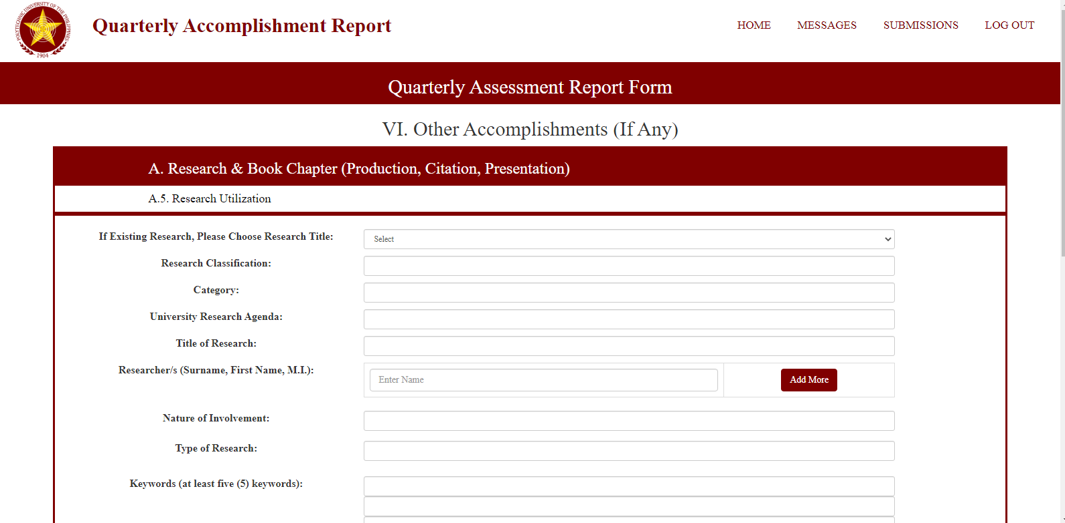

Figure 14: **GUI Design – QAR Form (11th Part)**

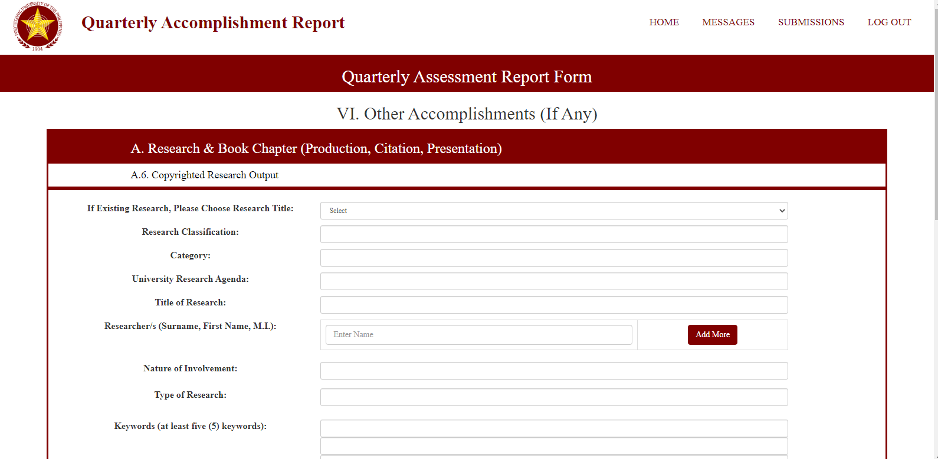

Figure 15: **GUI Design – QAR Form (12th Part)**

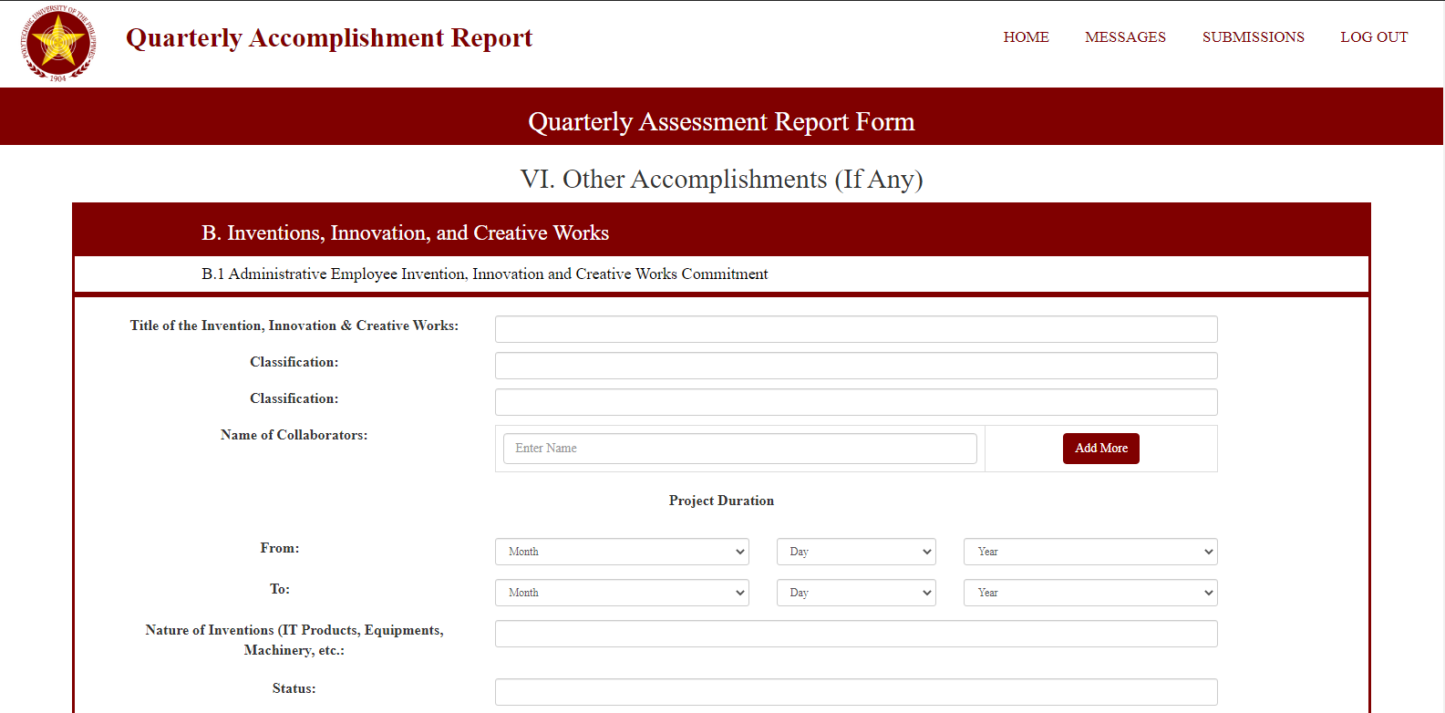

Figure 16: **GUI Design – QAR Form (13th Part)**

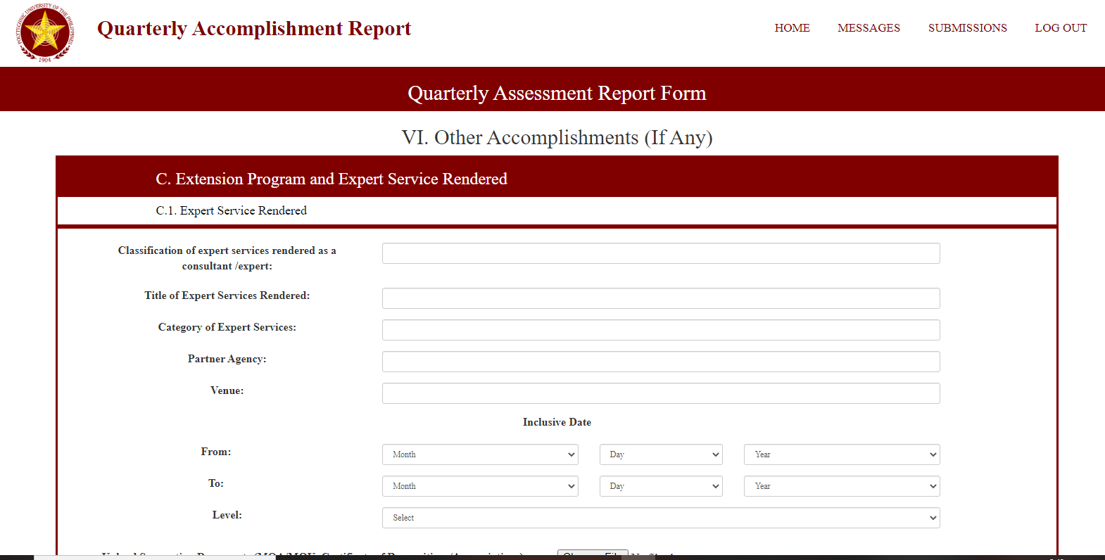

Figure 17: **GUI Design – QAR Form (14th Part)**

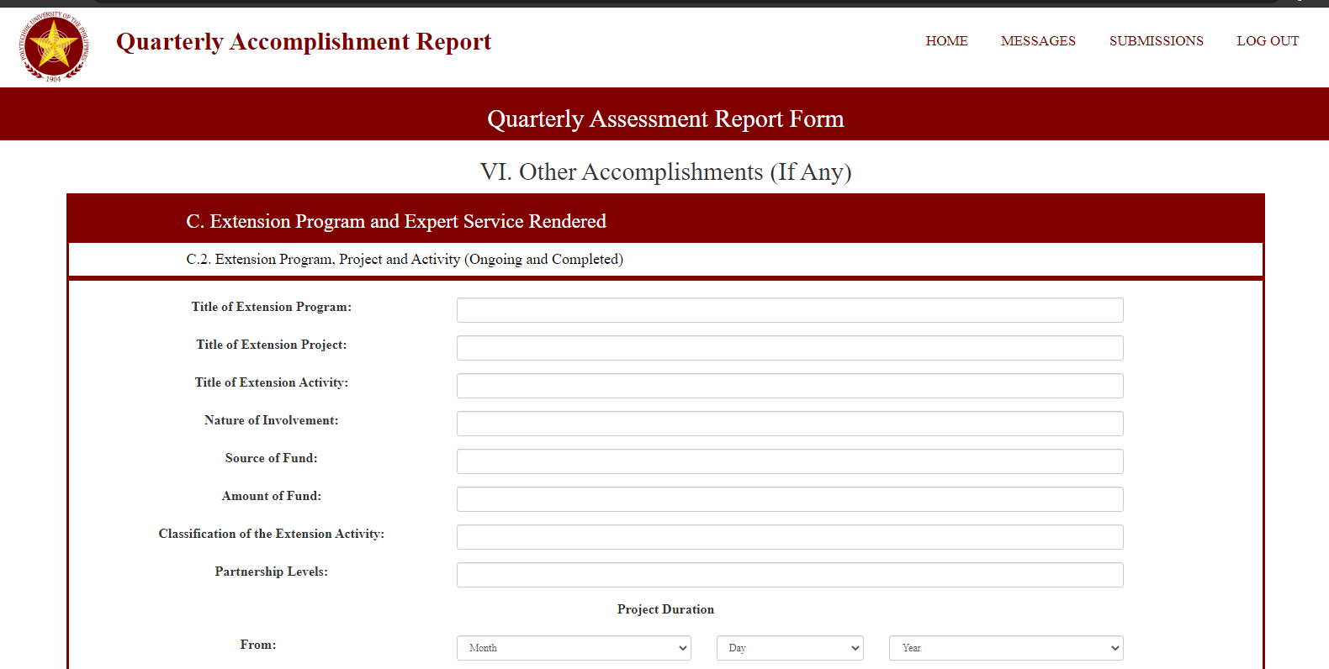

Figure 18: **GUI Design – QAR Form (15th Part) Top**

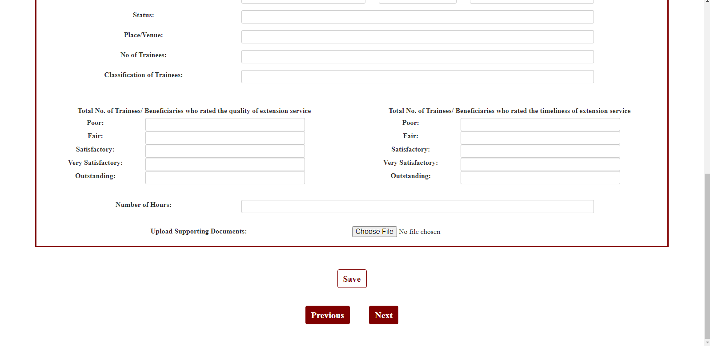

Figure 19: **GUI Design – QAR Form (15th Part) Bottom**

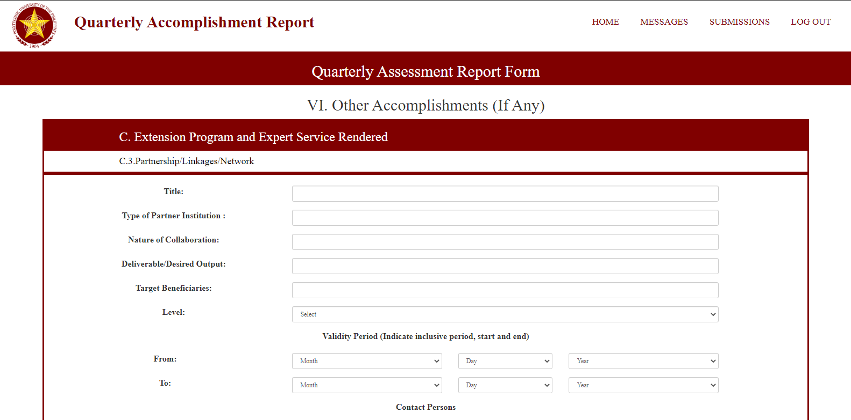

Figure 20: **GUI Design – QAR Form (16th Part)**

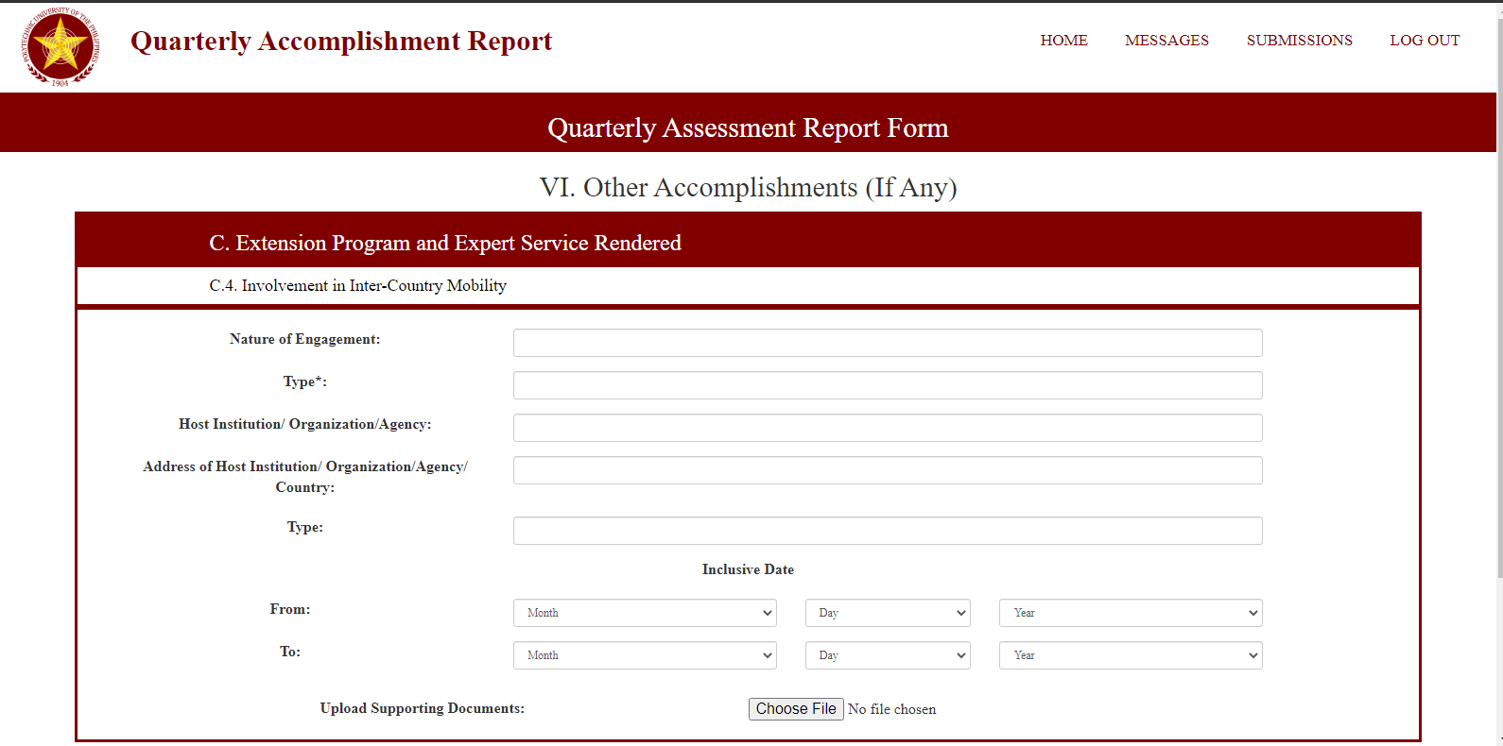

Figure 21: **GUI Design – QAR Form (17th Part)**

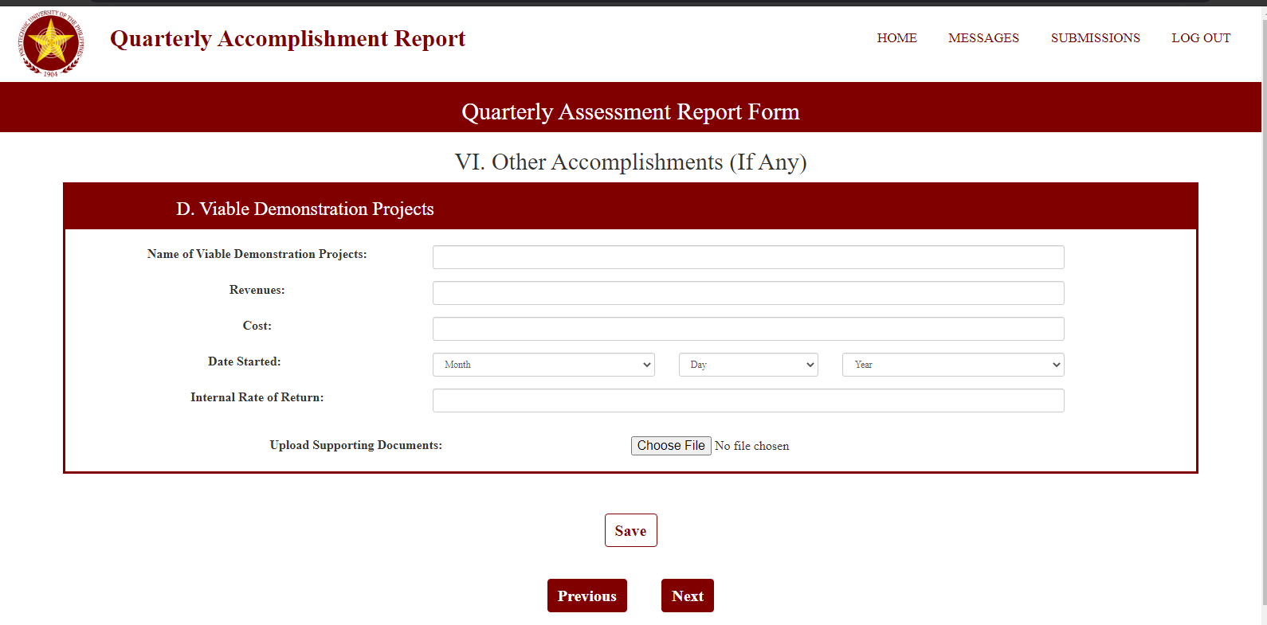

Figure 22: **GUI Design – QAR Form (18th Part)**

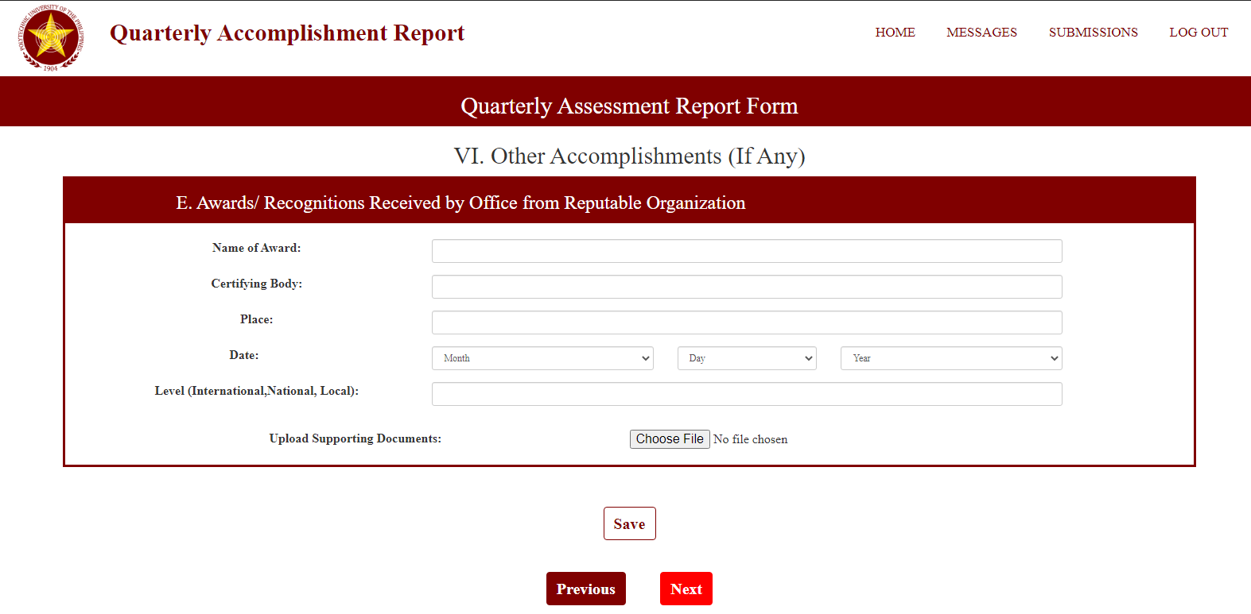

Figure 23: **GUI Design – QAR Form (19th Part)**

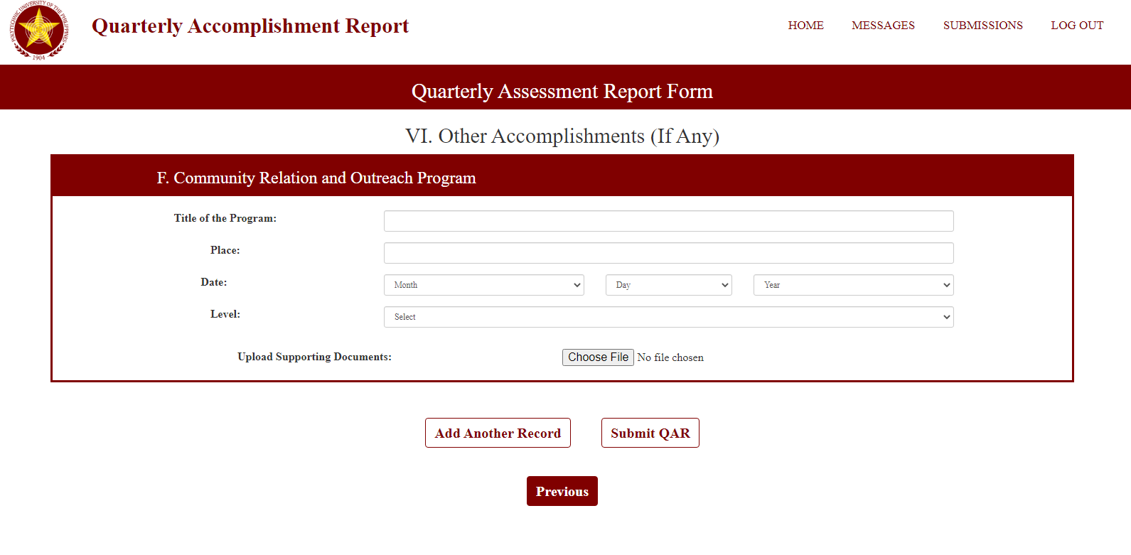

Figure 24: **GUI Design – QAR Form (20th Part)**